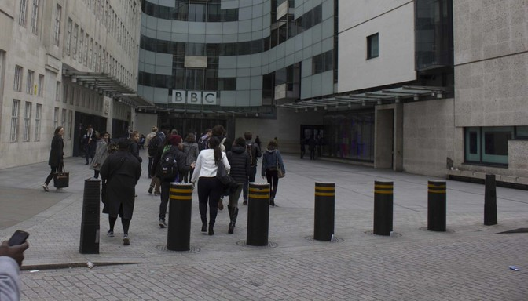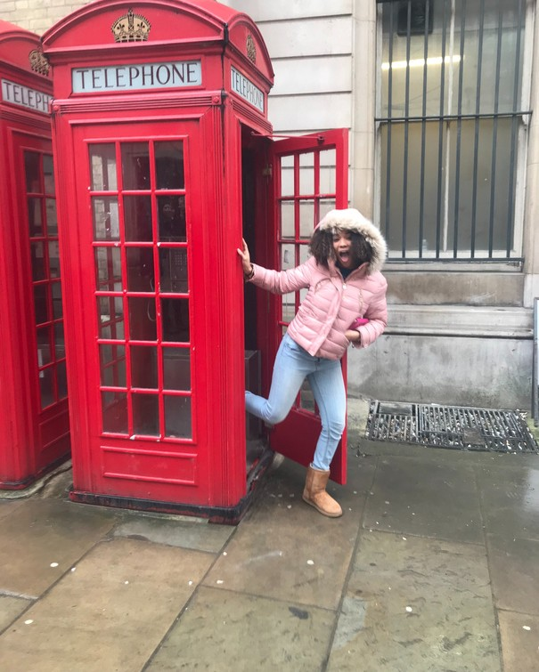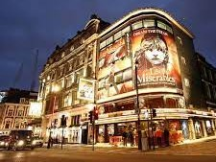

**SPEND WINTER IN EVANSTON SPRING BREAK IN LONDON**

WE'RE NOW ACCEPTING APPLICATIONS FOR THE

Global Media & Communications Seminar

Study the dynamic role of creative media in a globalized world with Instructor Jonah Zeiger during Winter Quarter 2023 (CMN 350). Then travel to London March 17 - 24, 2023 for an immersive experience in London's creative industries.

The trip will include lectures at The London School of Economics & site visits to major and innovative companies across film, television, music, theatre, comedy, art and publishing. There will also be opportunities to network with alumni and industry professionals as well as time to experience London's unique cultural scene both individually and as a group.

**Deadline to apply November 10** [**Learn more**](https://epics.soc.northwestern.edu/undergraduates/international-seminars/) **and** [**apply here**](https://northwestern.academicworks.com/opportunities/1264)

**Open to SoC undergrad**

**majors only**